

User Manual
DICOM Editor Tool 3.2.1

A DVTk based tool

Document version 1.3
Aug 12, 2009

Table of Contents

1 Introduction 3
1.1 Revision History 3
1.2 General 3
1.3 System Requirements 3
1.3.1 Operating system 3
1.3.2 Software requirements 3
2 Software installation 5
2.1 Installation of DICOM Editor tool 5
3 Editing a DICOM File 6
3.1 Selection of a DICOM File 6
3.2 Changing the value of an attribute 7
3.3 Adding/deleting of an attribute 8
3.3.1 Example of adding an attribute to the DICOM Header 9
3.4 Deleting selected attributes 10
3.5 Adding/deleting of a sequence item 11
3.6 Copy-Pasting Attributes in a DICOM File…………………………………….16
3.7 Saving a modified DICOM file 18
3.8 Find/Search an attribute 19
4 Creating a text file from the header of a DICOM file 20

Introduction

Revision History
Version | Date | Description
1.0 | December 21, 2006 | First version of this document, describing the functionality of version 2.8.4.
1.1 | December 22, 2006 | Corrections made after document review.
1.2 | June 10, 2008 | Releasing version 3.2.0 with .NET2.0 support
1.3 | Aug 12, 2009 | Releasing version 3.2.1 with DataGridView control

General
This DICOM Editor application is used for editing DICOM part-10 files and generating test data. It has the capability to:
- Display all DICOM attributes in tabular format with indicating beginning & ending of sequence items.
- Add/delete DICOM attributes.
- Add/delete DICOM sequence attributes and sequence items
- Modify existing attribute values.
- Create a text file of the DICOM Header
- Save the modified dataset as DICOM part 10 files as selected uncompressed transfer syntax.
- Display all the attributes in a DICOMDIR
- Finding/Searching an attribute among displayed attributes in case of large DICOM object.

System Requirements

Operating system
The following operating systems are supported:
- Windows NT 4 SP6a
- Windows 2000 Professional
- Windows XP Professional
- Windows 2003 Server

Software requirements
The following packages are required the installation of the software packages:

- Microsoft .NET framework 2.0

The Microsoft .NET framework software package is included in the installer of the DICOM Editor Tool.

See: http://www.dvtk.org for new versions and features.

Software installation

All the steps of the installation process are controlled by the DICOM Editor Tool installer package. During the installation process, the installer will check if the Microsoft .NET Framework R2.0 is already installed on the system. If present, this step of the installation process will be skipped.

Installation of DICOM Editor tool

Download or copy the file DICOM Editor.zip to a temp directory on the PC.
Double click (left mouse button) on the DICOM Editor.zip and extract the file DICOM Editor.exe to the temp directory.
Start the installation procedure by double clicking with the left mouse button on the file DICOM Editor.exe.
In the window “Microsoft .NET Framework 2.0 setup” select “I agree” to accept the license agreement. Press “install” to start the installation process. At the end of the installation procedure press “OK”
The Microsoft .NET Framework R2.0 software is installed.

After the .NET Framework software is installed, the installer package continues with the installation of the DICOM Editor software.
Follow the instruction in the installer window and accept the license agreement.
After the button “install” is pressed, the installation will start. At the end, press the “Finish” button. The DICOM Editor package is installed.

In windows “All programs” there is an entry created “DVTK”. When selecting DVTK, a submenu with all installed DVTK applications will be opened. From this submenu the DICOM Editor tool can be started. There is also a shortcut created on the desktop.

Editing a DICOM File

In the screen capture below, the User Interface of the DICOM Editor tool is displayed.

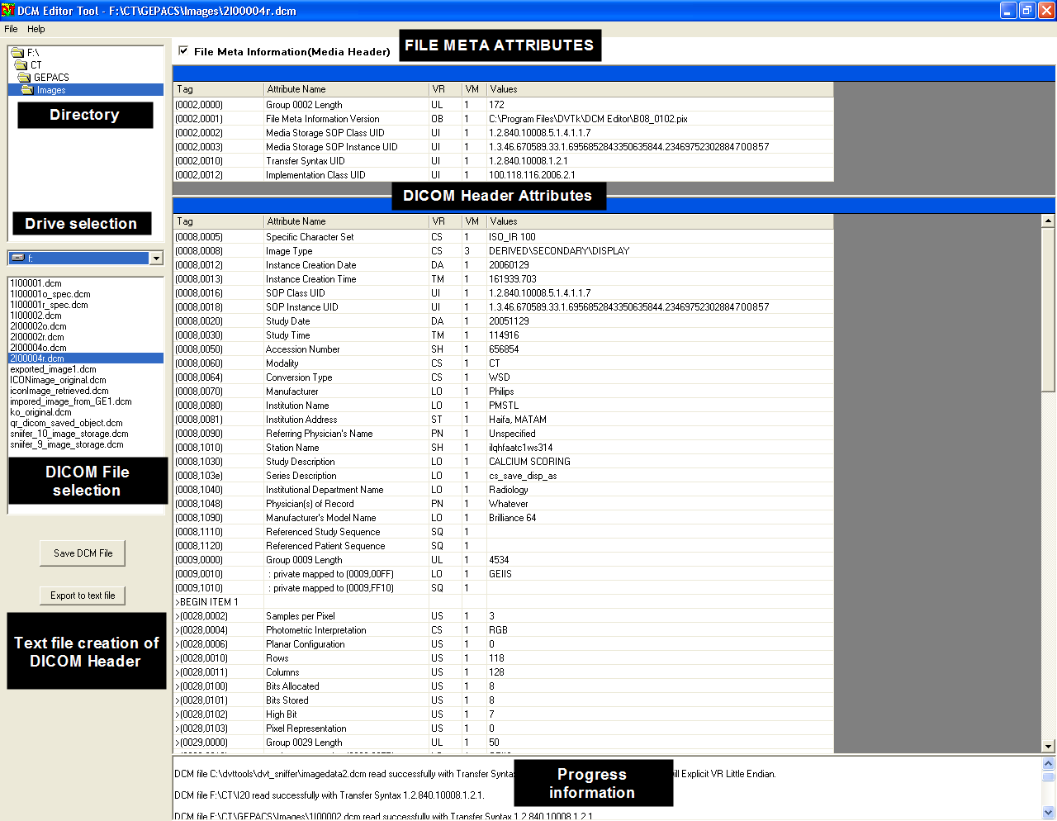

Selection of a DICOM File

Via the “Drive selection”, “Directory selection” and “DICOM File selection” controls, a DICOM file can be loaded into the DICOM Editor tool.
In the DICOM file selection window, all files with extension “dcm” and all files without extension will be displayed.
By selecting a file with the mouse, the header of the selected DICOM file will be displayed.
By default the tool will only display the DICOM attributes from group 8 and onwards.
Via the checkbox, the tool can also display the file meta information of the DICOM File. No changes can be made to the attribute values of the File Meta attributes. Also no attributes can be deleted/added to the File Meta Information.

Remark: the attributes 0002,0002 (Media SOP Instance UID) and 0002,0003 (Media SOP Instance UID) should contain the same value as the attributes 0008,0016 (SOP class UID) and 0008,0018 (SOP Instance UID). In case the value of the attributes 0008,0016 or 0008,0018 has been changed, the DICOM Editor tool copies automatically these modified values into the corresponding File Meta Information attributes. In this way, the saved (modified) file is a valid DICOM object file.

Changing the value of an attribute

The DICOM Header attributes are displayed in the columns:
- TAG (group, element)
- Attribute Name
- Value Representation (VR)
- Value Multiplicity (VM)
- Value

Only the value of an attribute can be modified by the DICOM Editor tool. The information about TAG number, Attribute name, Value Representation and Value Multiplicity comes from the DICOM library that is used by the editor tool for reference.

To modify the value of an attribute, position the mouse pointer to the value column of the attribute and click with the left mouse button.
The value of the attribute can be changed now by keyboard input.

Remark: the tool is not checking the validity of the entered modified value. This means that in case the file is saved with modified values which are not DICOM valid, an invalid DICOM file is created.

It is also possible to edit the value of attributes in the File Header. But doing so can cause inconsistencies in the file. In order to edit the File Meta Information attributes, the user must check the “Edit File Meta information” check box which will be visible on checking the File Meta Information checkbox.

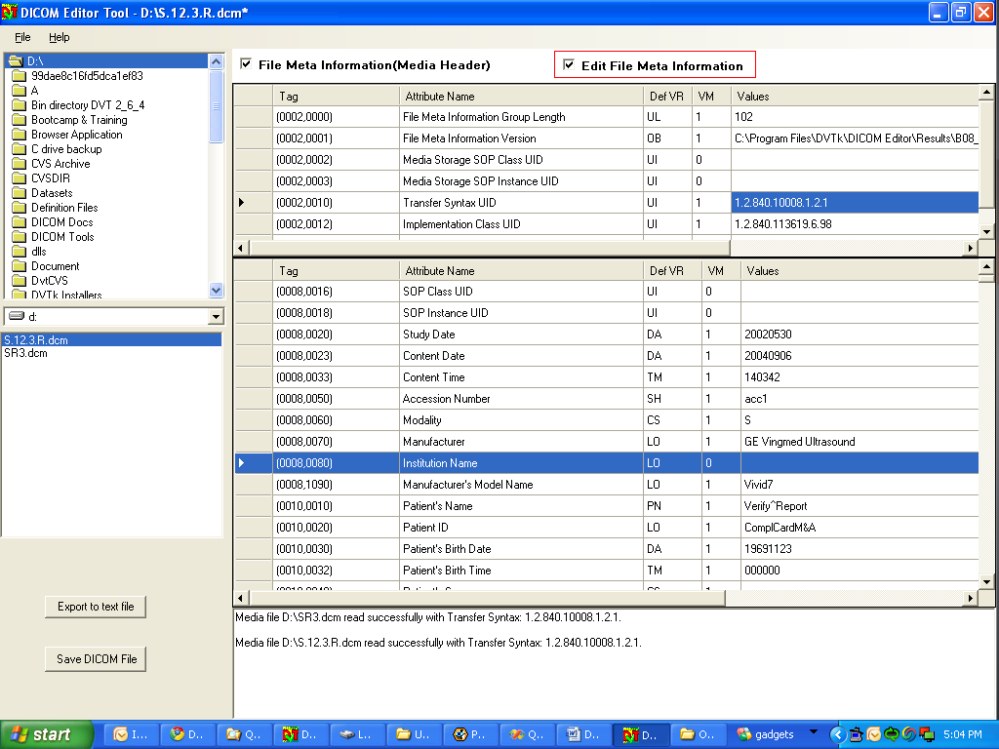

Adding/deleting of an attribute

To add an attribute to the DICOM Header, move the mouse pointer to an attribute tag click on the right mouse control button. DO NOT PRESS THE LEFT MOUSE CONTROL BUTTON BEFORE PRESSING THE RIGHT MOUSE BUTTON!!

After the right mouse control button is pressed, a menu is displayed with the functions:
- Add New Attribute
- Delete Attribute
- Find/Search Attribute

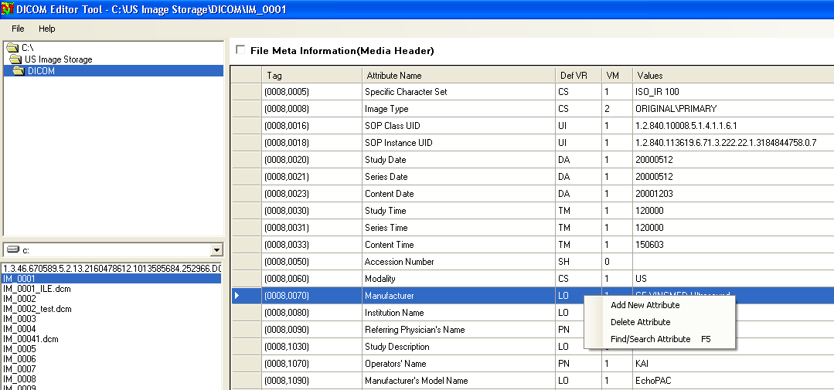

After selection of “Add New Attribute”, the Add New Attribute window pops up.

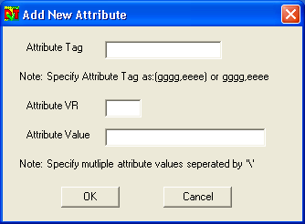

Enter the values for the fields:

- Attribute tag
- Attribute VR
- Attribute Value

Example of adding an attribute to the DICOM Header

Add the below attribute Patient Size to the DICOM Header.
Steps to be done:

(0x00101020,3,DS,1) "Patient's Size"

Where 0x00101020 = tag number 0010,1020
DS = VR value of the tag

- Enter in the “Attribute Tag” field the value 0010,1020
- Enter in the “Attribute VR” field the value DS
- Enter in the “Attribute Value” field, the value of the attribute i.e. 180

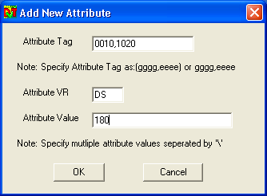

After pressing the OK button in the “Add New Attribute” window, the attribute “patient size” will be added to the DICOM Header.

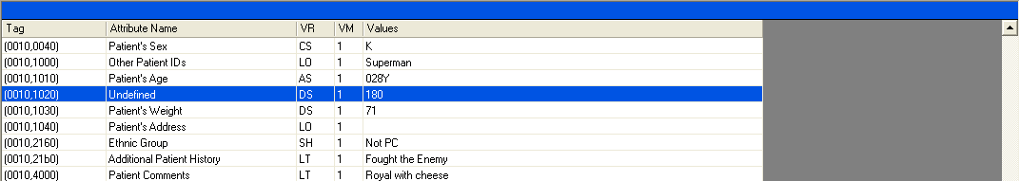

Remark: the attributes in the DICOM Header file are sorted in ascending order. The new attribute is inserted automatically at the correct location in the header.

For the new added attribute, the Attribute Name has the value “Undefined”. With the current version of the DICOM Editor tool, the attribute name is not automatically copied from the DICOM library file into the DICOM Header attribute list. After the modified file is saved and loaded again into the DICOM Editor tool, the correct value for Attribute Name is displayed. (See screen capture below)

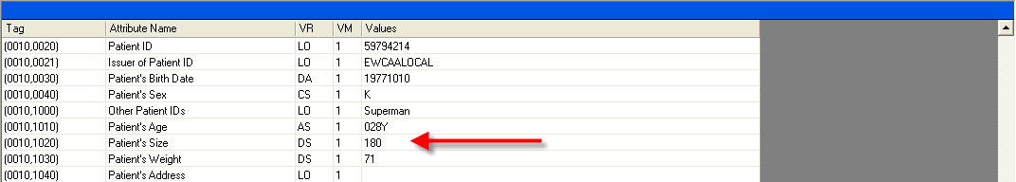

An attribute can be deleted from the DICOM Header by selecting the “Delete Attribute” function from the pop-up menu.

Deleting selected attributes
User can delete multiple attributes by selecting multiple rows through SHIFT+DOWN key and right click the selected part of the grid. Use context menu “Delete Selected Attributes” for deleting attributes.

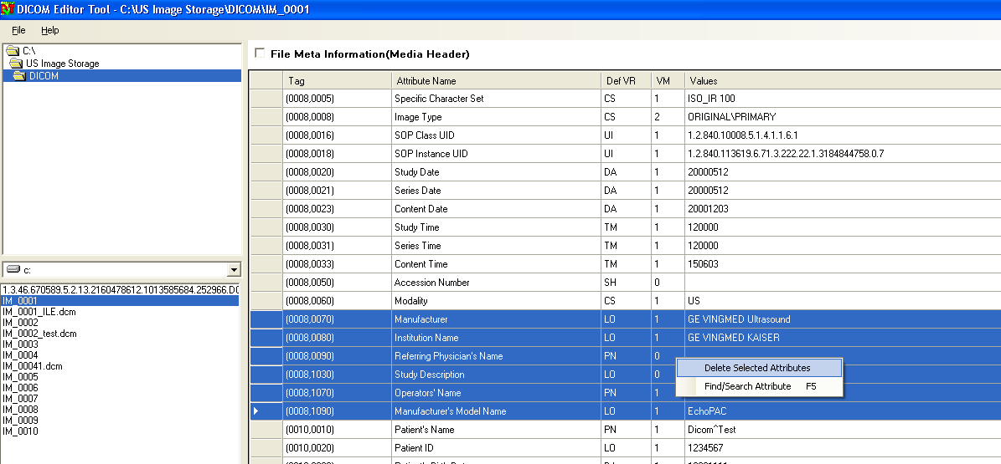

Adding/deleting of a sequence item

To add a sequence item to a sequence, move the mouse pointer to the sequence attribute tag (VR value = SQ) and click on the right mouse control button. DO NOT PRESS THE LEFT MOUSE CONTROL BUTTON BEFORE PRESSING THE RIGHT MOUSE BUTTON!!

After the right mouse control button is pressed, a menu is displayed from which the following functions can be selected:

- Add sequence item
- Delete Attribute

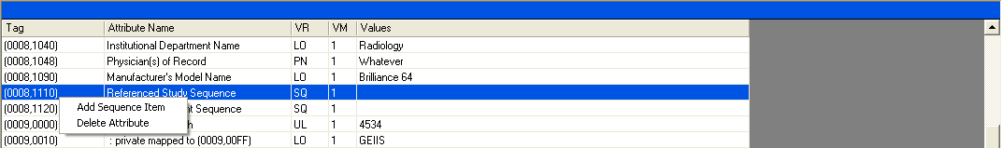

After selecting “Add Sequence Item”, the “Begin” and “END” delimiters of the sequence item are inserted.

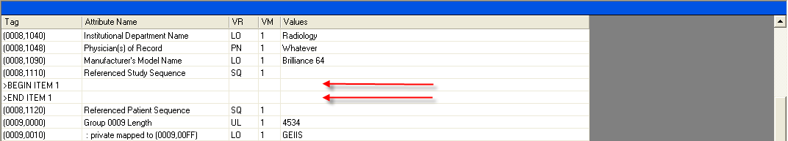

To add an attribute to the sequence item, move the mouse pointer to the
“BEGIN ITEM 1” line and press the right mouse control button.
A pop-up window appears, from which the function “Add New Attribute” can be selected.

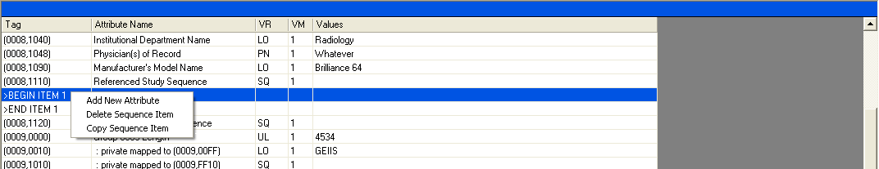

Via the “Add new Attribute” window (see previous chapter for explanation), new attribute(s) can be added to the sequence. In the example below, the sequence attributes 0008,1150 and 0008,1155 are added to the first sequence item of the sequence “Referenced Study Sequence”.

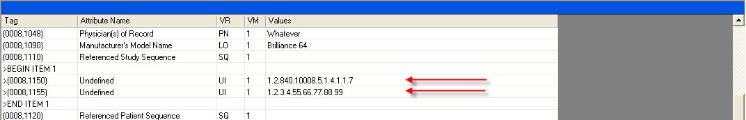

A sequence item can be copied by using the “Copy Sequence Item” function. To copy a sequence item, move the mouse pointer to the “BEGIN ITEM 1” line of the sequence item and press the right mouse control button. A pop-up menu appears, from which the function “Copy Sequence Item” is selected. (See figure below for an example.)

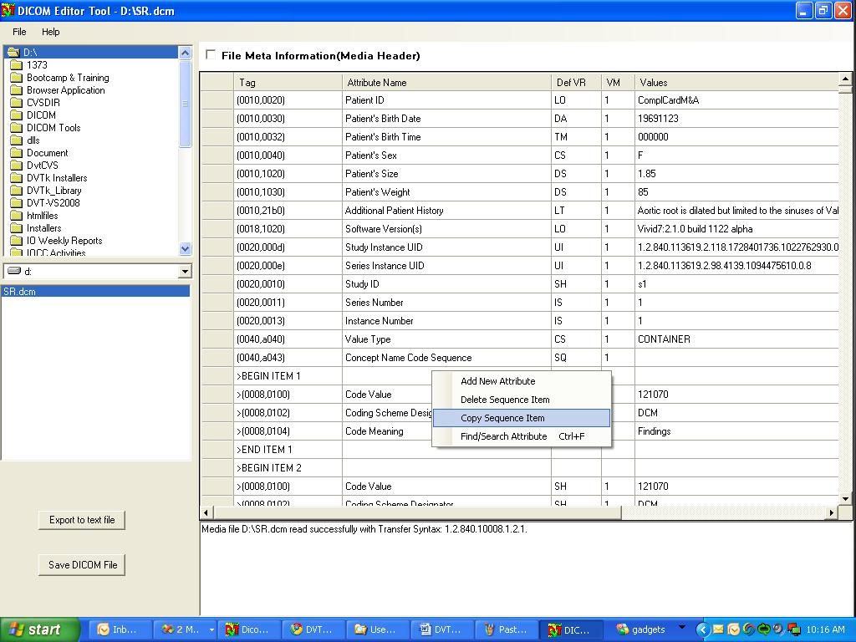

The copied sequence item can now be pasted in the following ways:

- To the end of the same sequence attribute or a different sequence attribute.
- Above another sequence item in the same sequence attribute or a different sequence attribute.
- Below another sequence item in the same sequence attribute or a different sequence attribute.

To paste the copied sequence item to the end of a sequence attribute, move the mouse pointer to the corresponding sequence attribute of the sequence item and press the right mouse control button. A pop-up menu appears, from which the function “Paste Sequence Item to End” is selected. (See figure below for an example.)
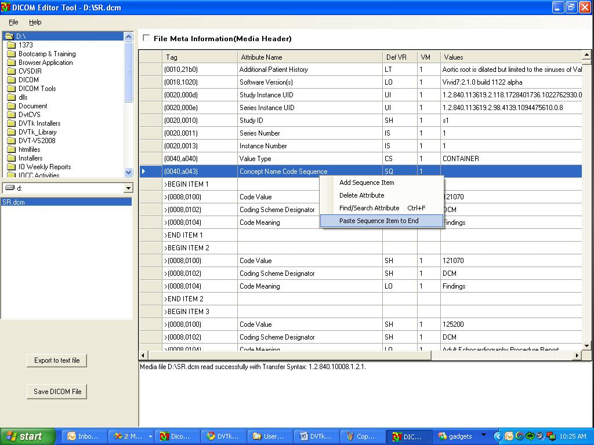

The sequence item is pasted to the end of the sequence attribute.

To paste the copied sequence attribute above another sequence item(part of the same sequence attribute or a different one), move the mouse pointer to the “BEGIN ITEM 1” line of the sequence item and press the right mouse control button. A pop-up menu appears, from which the function “Insert Sequence Item Above” is selected. (See figure below for an example.)
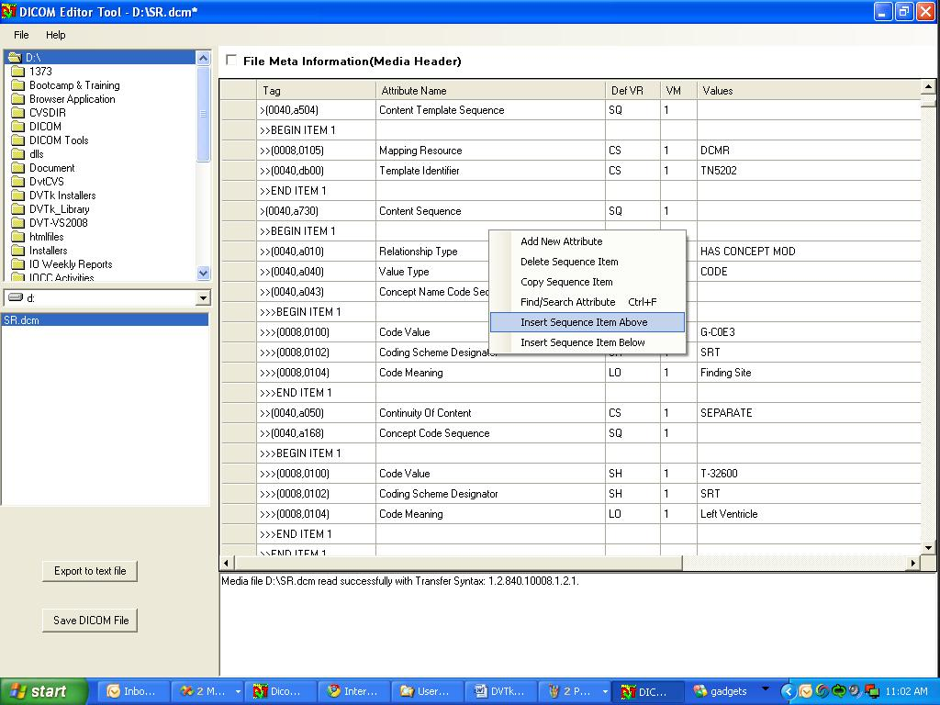

The sequence item is inserted above the selected sequence item as shown below.

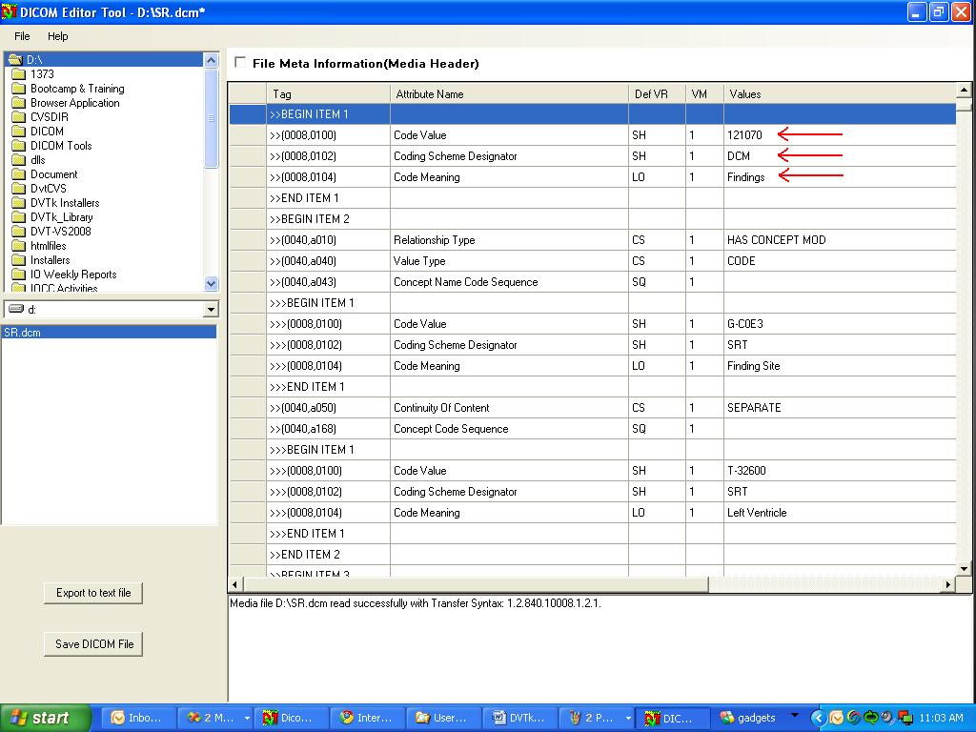

To paste the copied sequence attribute below another sequence item(part of the same sequence attribute or a different one), move the mouse pointer to the “BEGIN ITEM 1” line of the sequence item and press the right mouse control button. A pop-up menu appears, from which the function “Insert Sequence Item Below” is selected. (See figure below for an example.)
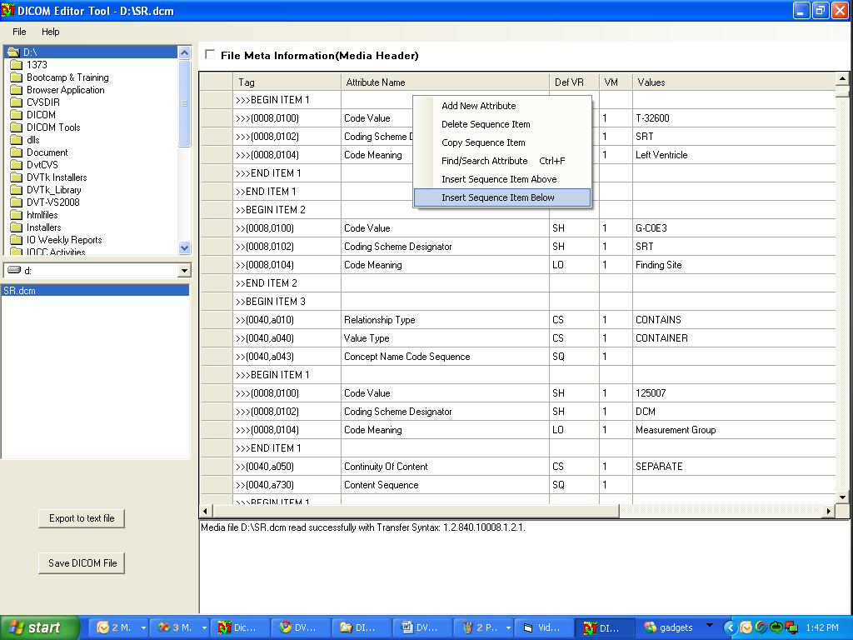
The sequence item is inserted above the selected sequence item as shown below.

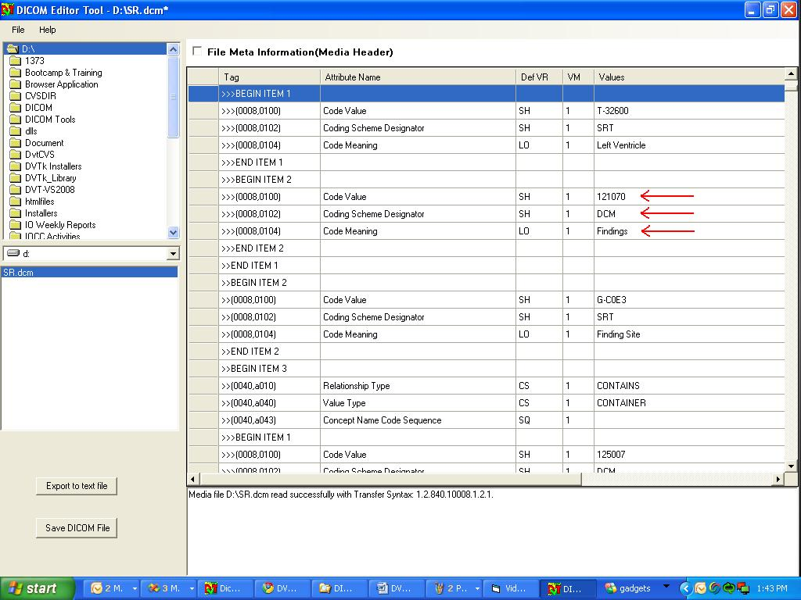

Via the “Delete sequence item” function, a sequence item can be deleted from a sequence.

Copy-Pasting Attributes in a DICOM File

To copy an attribute, move the mouse pointer to the attribute tag and click on the left mouse control button. This will highlight the row on which the attribute is present .DO NOT PRESS THE LEFT MOUSE CONTROL BUTTON BEFORE PRESSING THE RIGHT MOUSE BUTTON!! Once the row has been selected, click on the right mouse button.(If you want to copy a group of attributes, hold the “Ctrl” key and select multiple attributes as described above)

After the right mouse control button is pressed, a menu is displayed from which the following function must be selected:

- Copy Attribute(s)

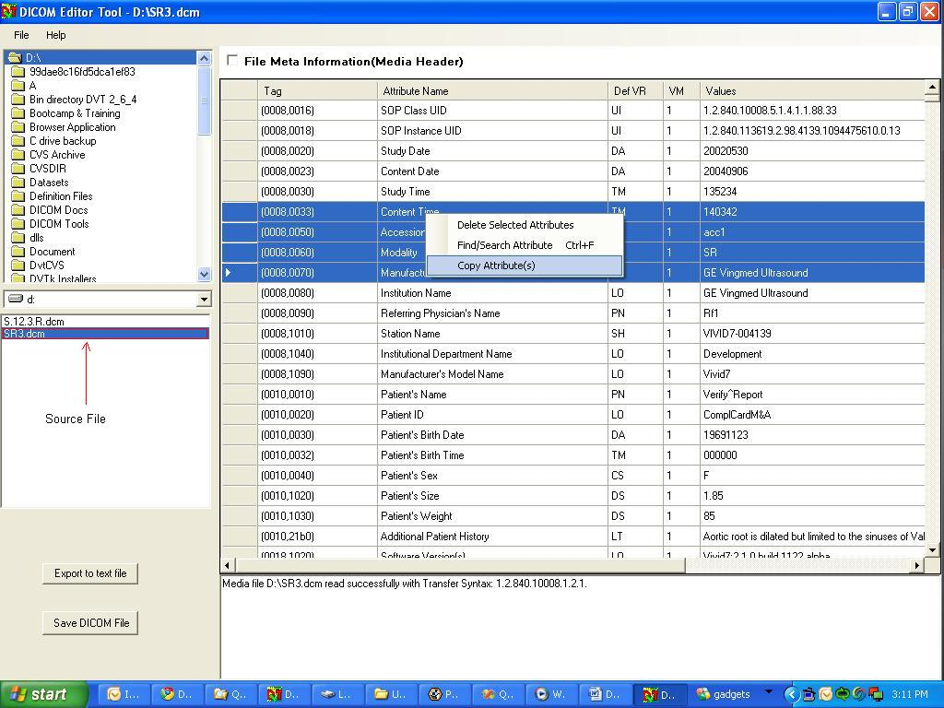

The copied attribute(s) can now be pasted into another DICOM File. One important point which the user must keep in mind is that the DICOM Editor does not allow duplication of attributes in a given DICOM file. So if the copied attribute(s) is pasted to a file whose dataset already has the given attributes, the Editor will automatically remove the duplicate entries.

To paste the copied attribute(s), open the DICOM File to which the attribute(s) must be copied to and press the right mouse control button. A menu is displayed, from which the following function must be selected.

- Paste Attribute(s).

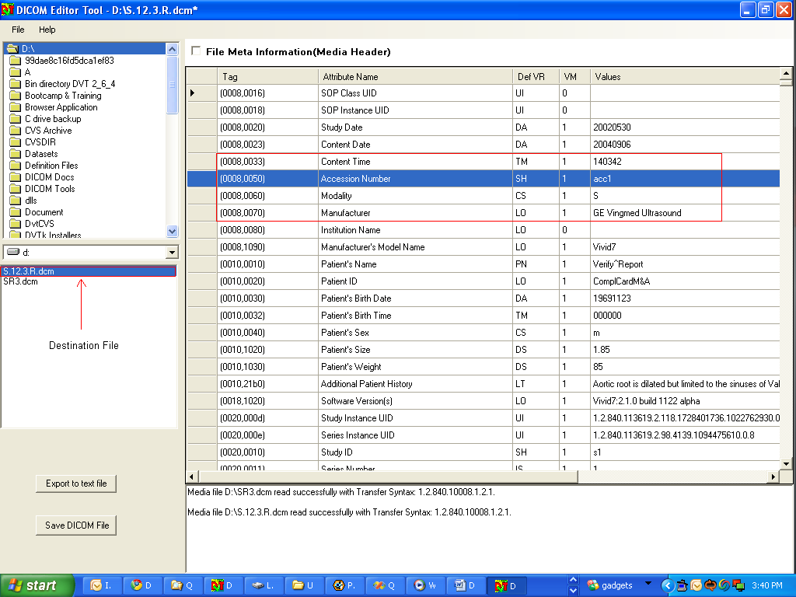

The copied attributes are now pasted in the DICOM File.

Saving a modified DICOM file

A modified DICOM file can be saved by using the “Save DICOM File” button at the left side of the screen. When using this button, the modified file will overwrite the original DICOM file.

It is also possible to save the modified file as a new file with selected uncompressed transfer syntax i.e. ILE, ELE, EBE. This can be done by using the “Save as DICOM file” from the File menu as shown below.

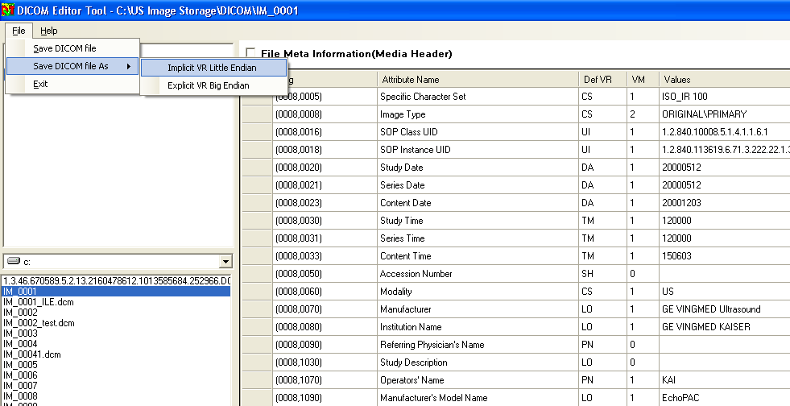

Find/Search an attribute
There is a need for search/find functionality, especially when you must edit a SR object which can be very long.

User can search attribute by right click the grid and selecting the context menu option “Find/Search Attributes” or alternatively by pressing F5. Fill the search criterion as in below dialog box and click OK. The result row will be displayed and selected on the screen.(Note: The user can search for sequence attributes also.)

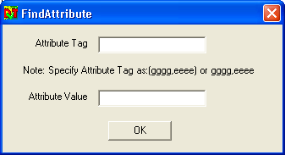

Creating a text file from the header of a DICOM file

Via the button “export to text file” a text file can be created with the contents of the complete DICOM Header (including the File Meta attributes).
The text file can be saved with any name at any place in the file system.

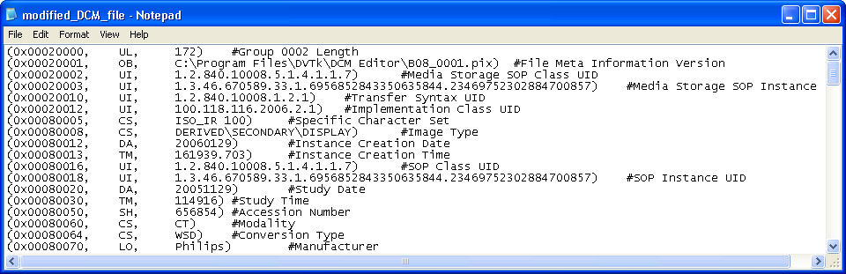

Example of a created text file

